|  |  |
| --- | --- |
| Date | 1.11.2023 |
| Team ID | NM2023TMID08614 |
| Project Name | Create a google business page |

**Problem Statement:**

Many businesses today struggle with establishing a strong online presence and reaching potential customers effectively. One significant challenge they face is the absence of a professional and attractive online platform that can showcase their products or services to a broader audience. Creating a Google Business Page is a crucial step in this digital age, but numerous businesses encounter obstacles in setting up and optimizing their page efficiently.

**Challenges Faced:**

**Lack of Technical Knowledge:**

Many business owners lack the technical expertise required to create and optimize a Google Business Page effectively. They might find it challenging to navigate the setup process, including adding accurate business information, high-quality images, and engaging content.

**Limited Online Visibility:**

Without a properly optimized Google Business Page, businesses struggle to appear in local search results. This limitation hampers their visibility to potential customers who are actively searching for similar products or services in their vicinity.

**Ineffective Brand Representation:**

Businesses often fail to represent their brand effectively on their Google Business Page. This includes showcasing positive customer reviews, responding to customer queries, and providing up-to-date information.

Inadequate brand representation can lead to a lack of trust among potential customers.

**Time Constraints:**

Business owners are typically occupied with various aspects of running their enterprises. Allocating time to create and maintain an online presence can be challenging, leading to delayed or incomplete setup of their Google Business Page.

**Competition:**

In competitive markets, businesses without a strong online presence are at a significant disadvantage. Rival companies with well-optimized Google Business Pages attract a larger share of potential customers, leaving businesses without an optimized page struggling to keep up.

**Ideation Phase**

**Brainstorm & Idea Prioritization**

**Brainstorm & Idea Prioritization :**

Brainstorming provides a free and open environment that encourages everyone within a team to participate in the creative thinking process that leads to problem solving. Prioritizing volume over value, out-of-the-box ideas are welcome and built upon, and all participants are encouraged to collaborate, helping each other develop a rich amount of creative solutions.

Use this template in your own brainstorming sessions so your team can unleash their imagination and start shaping concepts even if you're not sitting in the same room.

**Step-1: Team Gathering, Collaboration and Select the Problem Statement**

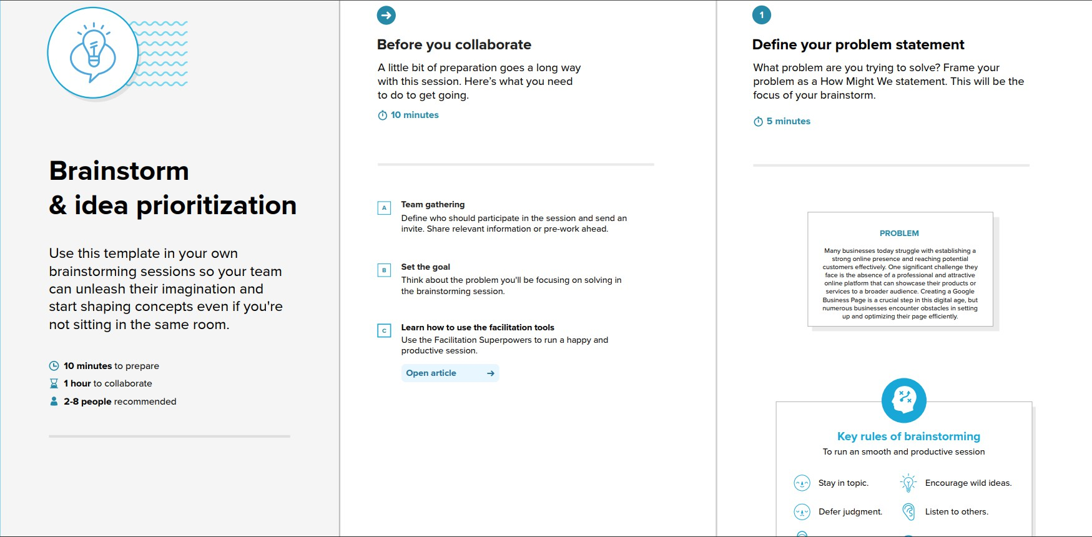

**Step-2: Brainstorm, Idea Listing and Grouping**

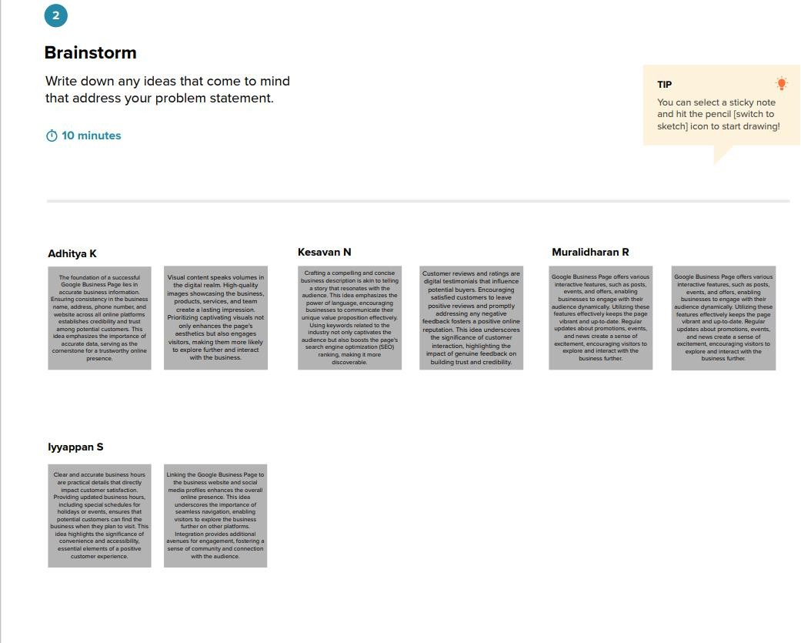

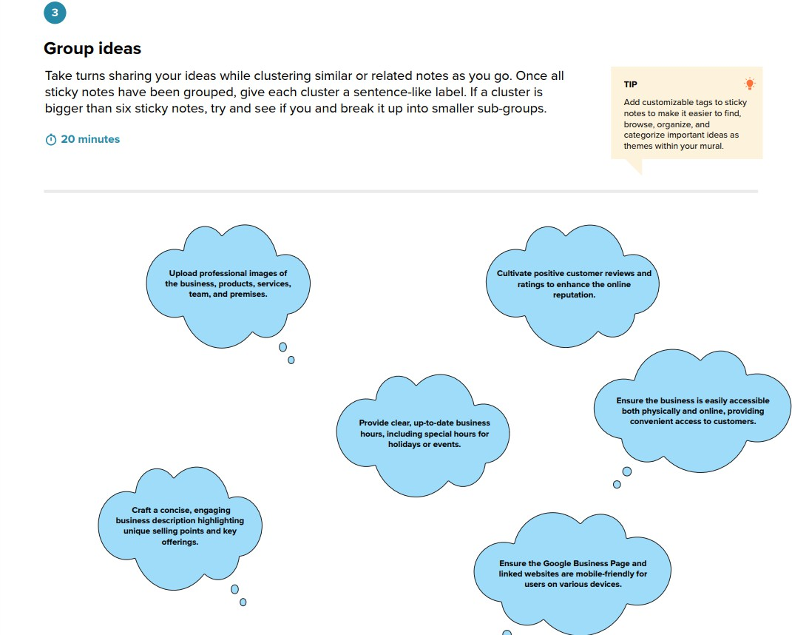

**Step-3: Idea Prioritization**

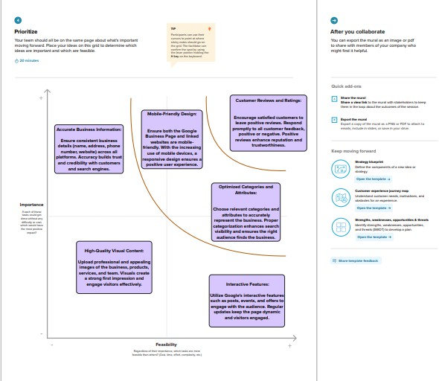

**Ideation Phase Empathize & Discover**

**Empathize and Discover:**

Empathizing and discovering are essential steps in creating a compelling Google Business Page. Understand your customers' needs, preferences, and concerns to tailor your content accordingly. Ask questions, engage with their feedback, and conduct surveys to discover what they value most. By genuinely understanding them, you can create a page that resonates, building trust and customer loyalty.

**CREATE A GOOGLE BUSINESS PAGE:**

